**Challenge 10.**

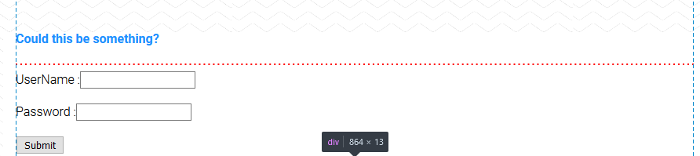

1. My first response is to inspect page source. It seems pretty simple. I then try to login via a hidden comment as done in a previous challenge:

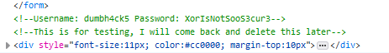

No results.

1. This leads me to load up Burp Suite and attempt to intercept traffic from the webpage and see what exactly is being sent. The data that is being sent isn’t being sent very securely:

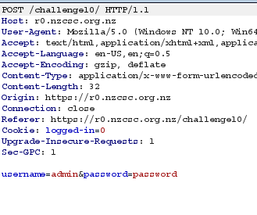

1. But the return data is interesting. It doesn’t seem to be receiving any real validation for the password. This makes me wonder what criteria is actually used for the validation protocol and I decide to change the cookie *logged-in=0*
2. Modifying the cookie sends me to a new page:



1. So I double down and change the cookie again to *logged-in=1.* And this returns the flag: 